Ground-fault Protection for DC Systems
Direct current (DC) systems have positive and negative buses. If either bus is intentionally grounded, then it is referred to as a grounded system. If neither bus is grounded, then it is referred to as an ungrounded DC system. A ground fault on a DC system may cause damage to the source as well as in the field. If the system is ungrounded, then it is possible to use a ground-fault relay by installing a ground-reference module between the two buses to establish a neutral point (see Figure 1). The ground-fault relay uses this reference to create a path for fault current to flow, which can then be measured. The ground-reference module is selected to limit fault currents to a very low value.
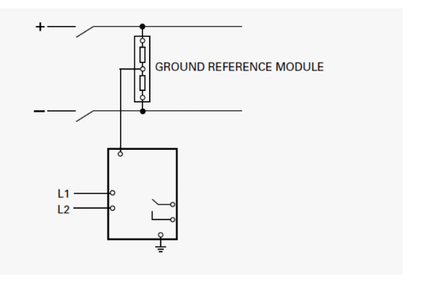

Source: https://www.littelfuse.com/marketing-pages/industrial/ground-fault-knowledge-center/~/~/~/~/~/link.aspx?_id=60A6CBD73C0342E9B826F53A69FB2DF6&_z=z

